Unit 4 Correlation and Bivariate Regression

In this unit consideration is given to measuring association between varialbles and if they can be linked theoretically how build a model of the relationship. We will begin with only two variables and in later chapters more variables will be introduced.

Correlation

The Pearson Product Moment Correlation Coefficient is a measure of the degree of association between variables. It takes a value between -1 and 1. A value of r near 1 indicates strong positive association e.g. a persons height and weight where as a value of r near -1 indicates a strong negative linear association, e.g. amount to drink and performance in a test.

Positive Correlation (r > 0) Negative Correlation (r <0)
No Signficant Correlation
The Pearson correlation coefficient is computed from 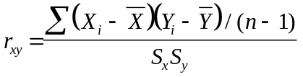; this formula is available in most packages including SPSS. SPSS also gives a significance level, if this is less thn 0.05 then the coefficient is judged significant. However, one should not consider the coefficient on its own, statter plots should also be examined. The following illustrates the dangers of ignoring the plots.

Outlier effect turns a r = 0 .002 to r = 0.91. The outlying point should perhaps be removed. | Non - linear relationship ( r = -0.02). The Pearson correlation coefficient is purely a meaure of linear association. Yet many variables have strong linear association, such as economies of scale.

As an example of using SPSS, load the file Houses.sav and go to analyze and then correlation and enter the variables, Price, Age, Area and Totrooms.
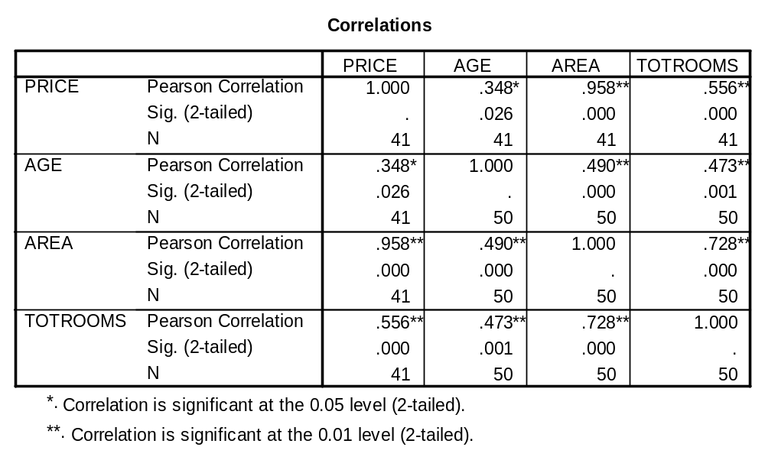
A matrix scatter plot is also helpful:

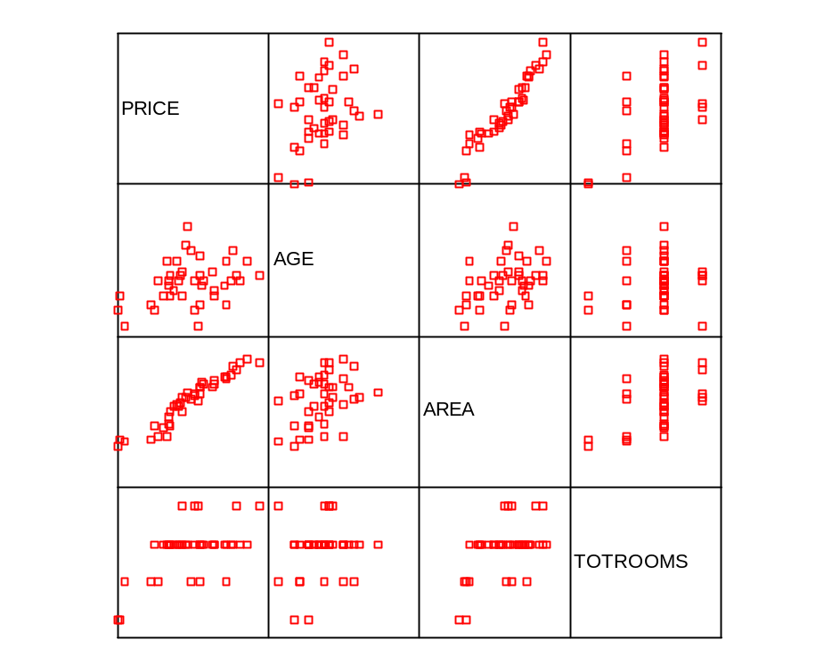

Thus a strong positive correlation is suggested between Price and Area, a lesser correlation between Price and Totrooms and Area and Totrooms and a weaker correlation between Price and Age and Age and Area.

Consider the population data from World96.sav: The Pearson Correlation Matrix is: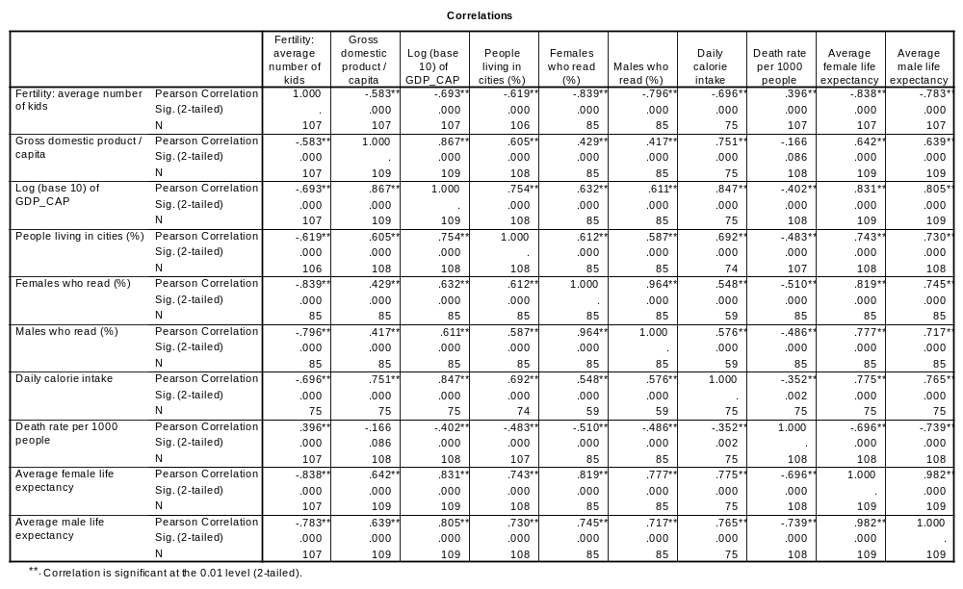
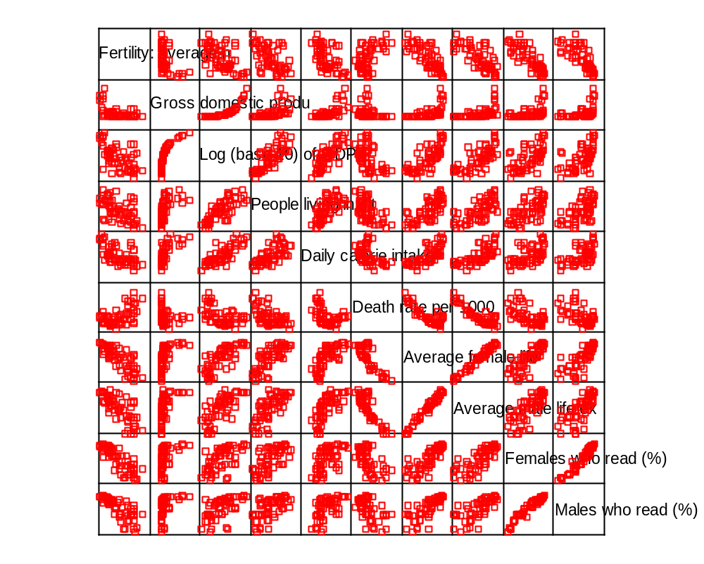

Clearly from the matrix plot one has to take great care in interpreting these correlations.

Regression

“Finding a relationship between variables and forming a model”. An equation is found which relates independent variable(s) or stimuli to a dependent variable or response. This method was first developed by Legendre in 1805

Assumptions:

1. The relationship is sensible.

2. The relationship is linear.

3. Errors are independent and normally distributed.

Consider trying to explain a Japanese cars acceleration in terms of its horsepower. First plot a scatter plot:

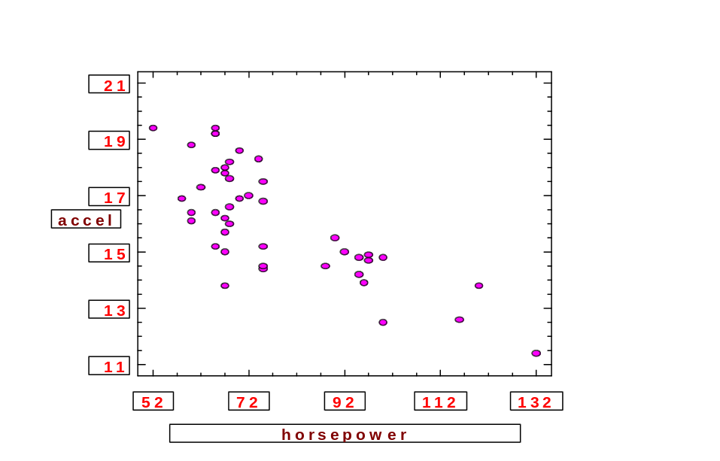

This seems although there could be a straight line relationship. Now find the line through the data which minimises the sum of squared errors from the line.

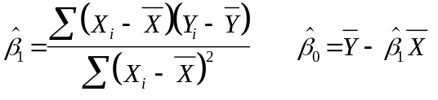
Regression Analysis - Linear model: Y = a+bX
--------------------------------------------------------------------------------
Dependent variable: accel SELECT origin Independent variable: horsepower
--------------------------------------------------------------------------------
Standard T Prob.
Parameter Estimate Error Value Level
--------------------------------------------------------------------------------
Intercept 22.6005 0.872175 25.9128 .00000
Slope -0.084101 0.0110172 -7.63358 .00000
--------------------------------------------------------------------------------
Analysis of Variance
--------------------------------------------------------------------------------
Source Sum of Squares Df Mean Square F-Ratio Prob. Level
Model 97.563842 1 97.563842 58.27152 .00000
Residual 70.320476 42 1.674297
--------------------------------------------------------------------------------
Total (Corr.) 167.88432 43
Correlation Coefficient = -0.762324 R-squared = 58.11 percent
Stnd. Error of Est. = 1.29395

From this one can say that Acceleration = 22.6 -0.084*horsepower

But is this reliable?

Must check the residuals which are the observed value minus the fitted value. These should be normally distributed and when plotted against the fitted values appear as a random scatter:

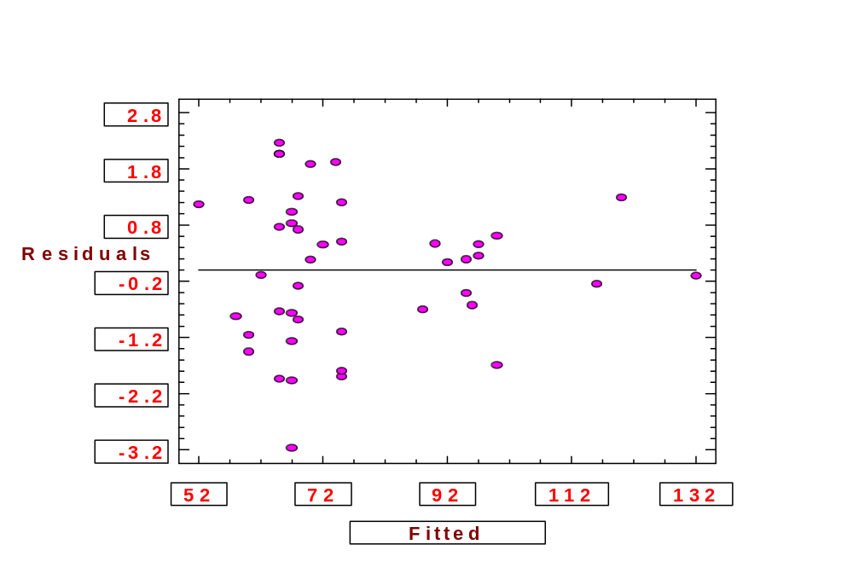

More variables can be added to give a better explanation but great care has to be taken to ensure the correct model specification.

An example of an extended model is:

Independent variable coefficient std. error t-value sig.level
--------------------------------------------------------------------------------
CONSTANT 1.282875 19.888856 0.0645 0.9489
horsepower -0.123981 0.023382 -5.3024 0.0000
weight 0.004556 0.001214 3.7520 0.0006
.year 0.204571 0.242043 0.8452 0.4032
price -0.00047 0.000264 -1.7830 0.0824
--------------------------------------------------------------------------------
R-SQ. (ADJ.) = 0.6729 SE= 1.130035 MAE= 0.845716 DurbWat= 1.751
Previously: 0.5757 1.287139 0.988540 2.094
44 observations fitted, forecast(s) computed for 107 missing val. of dep. var.

The residual plot is:

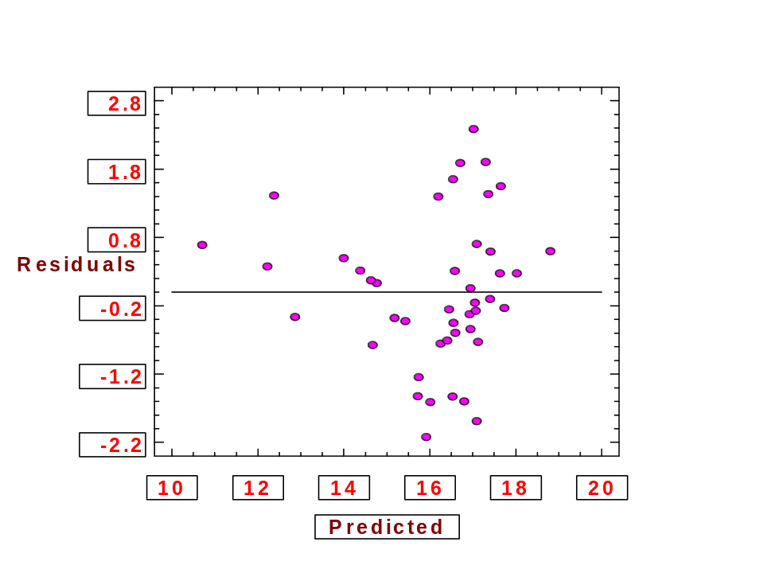

This plot causes concern and suggests that there is a non linear relationship.
Statistical Modelling

Statistical modelling is the attempt to explain changes in some phenomena as a result of influencing variables. Linear Regression is often used to do this and involves estimating the coefficients of the explanatory variable or independent variables or stimuli that go to predict the dependent variable or response.. Consider the example of a restaurant owner who thinks that sales of pizzas in cities are dependant primarily on the size of the student population. To test this he gathers the data which is tabulated below:

City | Student Population (1000s) | Annual sales (£1000s)
1 | 2 | 58
2 | 6 | 105
3 | 8 | 88
4 | 8 | 118
5 | 12 | 117
6 | 16 | 137
7 | 20 | 157
8 | 20 | 169
9 | 22 | 149
10 | 26 | 202

To test this the data is first plotted on a scatter diagram and is displayed below:

It looks although a straight line positive relationship may hold indeed the correlation coefficient is 0.905 with a P value = 0.000.

Plot the “best” straight line through the data and calculate the equation of the line.

Regression is away of doing this and estimates the coefficients or parameters of the model :
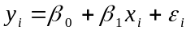
in such away that the sum of squares of the errors, or residuals, are minimised i.e.:

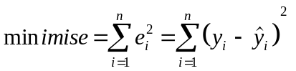
The restaurant owner uses SPSS to compute the model and gets the following output:

* * * * M U L T I P L E R E G R E S S I O N * * * *

Listwise Deletion of Missing Data

Equation Number 1 Dependent Variable.. SALES

Block Number 1. Method: Enter STUDENTS

Variable(s) Entered on Step Number
1.. STUDENTS

Multiple R .95012
R Square .90273
Adjusted R Square .89058
Standard Error 13.82932

Analysis of Variance
DF Sum of Squares Mean Square
Regression 1 14200.00000 14200.00000
Residual 8 1530.00000 191.25000

F = 74.24837 Signif F = .0000

------------------ Variables in the Equation ------------------

Variable B SE B Beta T Sig T

STUDENTS 5.000000 .580265 .950123 8.617 .0000
(Constant) 60.000000 9.226035 6.503 .0002

End Block Number 1 All requested variables entered.

Is this any good? Is it reliable?

The value R² the coefficient of determination is often used as a test of quality. This is calculated as:

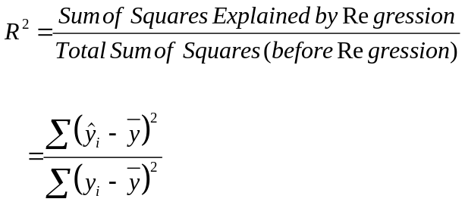

In this case R² is over 90% and suggests that 90% of the variation in the sales of pizzas is explained by the model. Generally one wishes R² to be as close to 100% as possible. However, it is dangerous to rely on R² one must consider the assumptions behind the model and diagnose the model accordingly.

The assumptions to consider are:

1. The model makes theoretical sense.
2. The errors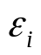are independent of one another (uncorrelated) and normally distributed with mean zero.
3. The parameters are constant over time

Diagnostics

To diagnose the model with respect to these assumptions the following methods are available:

1. Is the relationship sensible?

2. Examine the signs of the coefficients - are they sensible?

3. Test the errors for a zero mean and for normality. To do this one can look at a boxplot and a normal probability plot (normal P-P plot in SPSS) of the residuals. (The residuals are the observed values minus the fitted values).

The residuals should always be plotted against the predicted values. They can also be plotted against the explanatory variable, (why?).

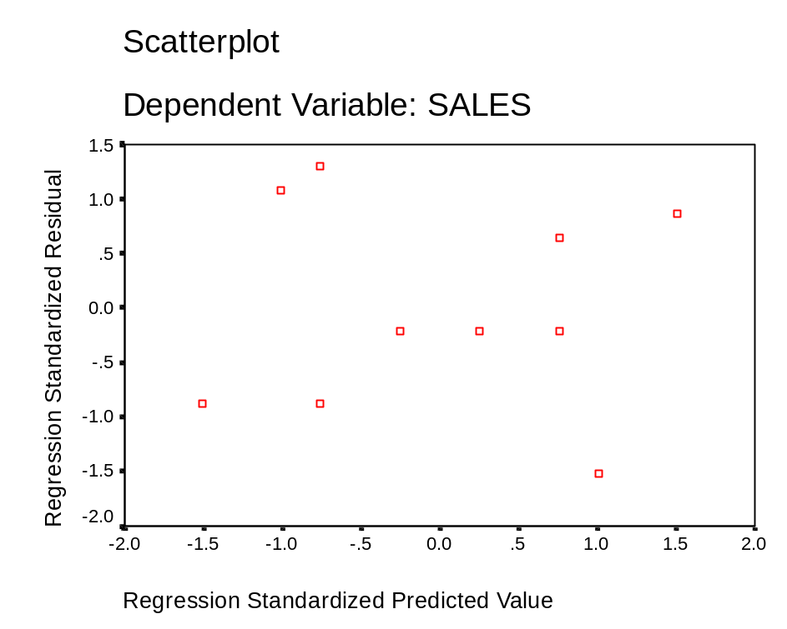
This analysis allows correlation to be detected, non constant variance (hetroscadisity) and influencing points to be detected. Fortunately the residuals appear randomly scattered as was hoped for.

Often one will work with the standardised residuals (SR). These are computed automatically from 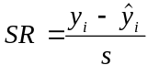 were s is the standard deviation of the residuals. Absolute values of SR > 3 indicate a probable deviant requiring investigation. Absolute values of SR > 2 but < 3 indicate a possible deviant.

Are the coefficients significantly different from zero?

To assess this they are compared to their standard errors and if they are then approximately they should be more than twice their standard error, (why?). More formally the T-ratio is computed from

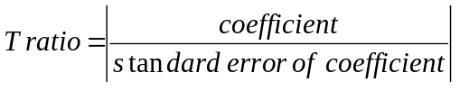

This is tested against the Student t distribution i.e. the T ratio is compared to 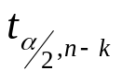
k = the number of parameters including 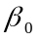

The hypothesis H₀: the coefficient is not significantly different from zero
is test against
H₁: the coefficient is significantly different from zero

Reject the null hypothesis (H₀) if the T ratio is less than the table value.

The F test allows one to test if a linear form between y and x exists. The test is

H₀: All the 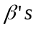equal zero
V
H₁: At least one of the do not equal zero.

This is compared to the F- distribution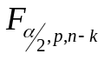, where p is the number of independent variables.

For both the above tests P values are computed automatically by most computer packages.

Example

A certain type of meat processing can begin once the pH level in the muscle of a slaughtered steer drops to 6.0

Steer | Time after Slaughter (hours) | pH
1 | 1 | 7.02
2 | 1 | 6.93
3 | 2 | 6.42
4 | 2 | 6.51
5 | 4 | 6.07
6 | 4 | 5.99
7 | 6 | 5.59
8 | 6 | 5.80
9 | 8 | 5.51
10 | 8 | 5.36

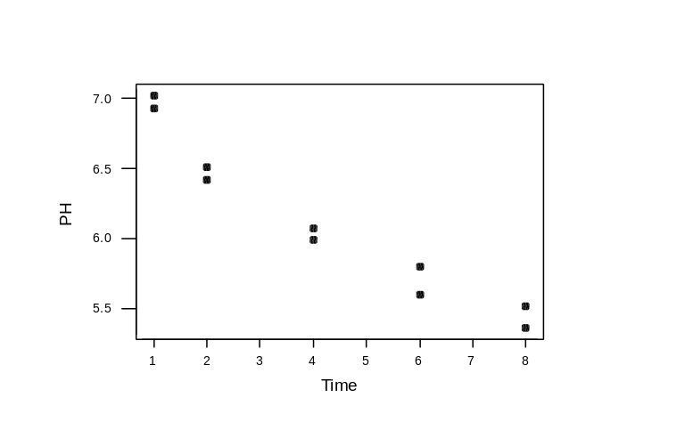

Correlations (Pearson)

Correlation of Time and PH = -0.966, P-Value = 0.000

Regression Analysis

The regression equation is
PH = 7.00 - 0.209 Time

Predictor Coef StDev T P
Constant 6.99649 0.09691 72.20 0.000
Time -0.20869 0.01970 -10.59 0.000

S = 0.1595 R-Sq = 93.3% R-Sq(adj) = 92.5%

Analysis of Variance

Source DF SS MS F P
Regression 1 2.8570 2.8570 112.23 0.000
Residual Error 8 0.2036 0.0255
Total 9 3.0606

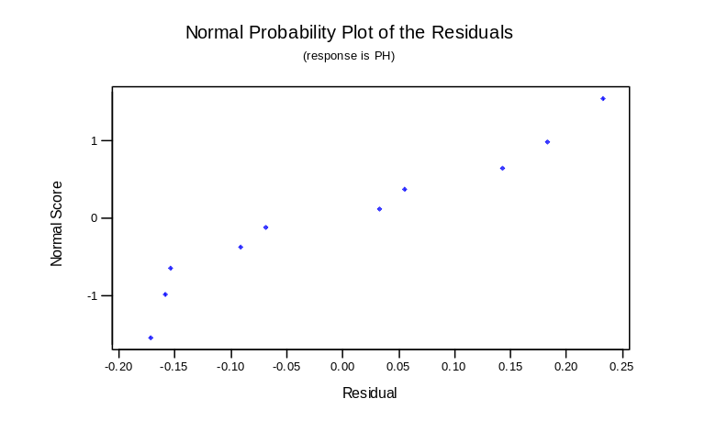

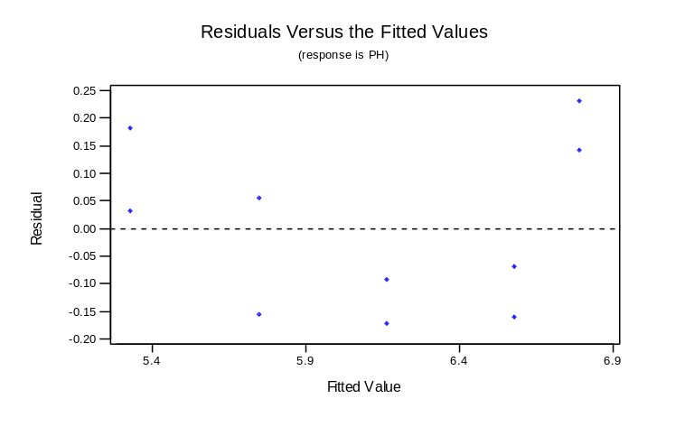
Take natural logs of time

Correlations (Pearson)

Correlation of logpH and PH = -0.991, P-Value = 0.000

Regression Analysis

The regression equation is
PH = 6.98 - 0.726 logpH

Predictor Coef StDev T P
Constant 6.98363 0.04853 143.90 0.000
logpH -0.72566 0.03443 -21.08 0.000

S = 0.08226 R-Sq = 98.2% R-Sq(adj) = 98.0%

Analysis of Variance

Source DF SS MS F P
Regression 1 3.0065 3.0065 444.31 0.000
Residual Error 8 0.0541 0.0068
Total 9 3.0606

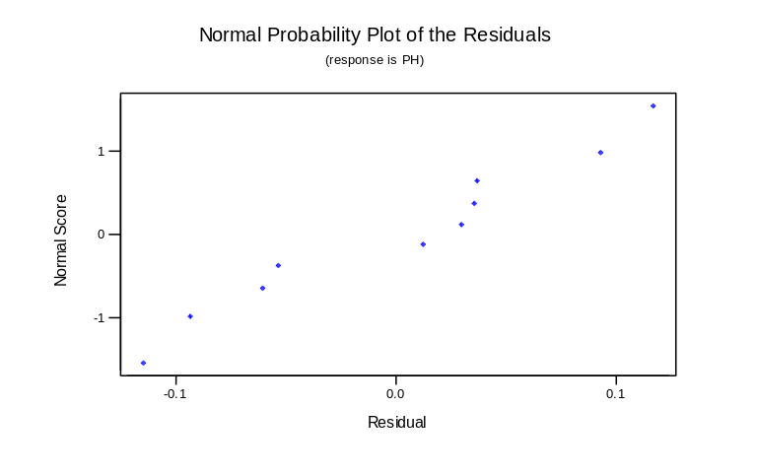
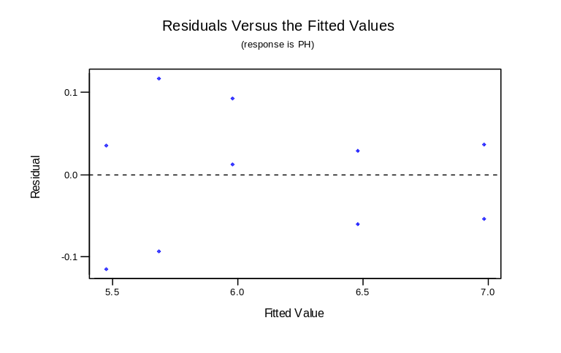

Detecting Differences Between Goups

Analysis of Variance (ANOVA) is used to determine if there is significant difference between groups. Typically samples are taken from a population and have one or more factors operating at two or more levels. To do this the varience between groups is compared accounting for the variance within groups, (the noise). The greater the variance within groups the harder it is to detect any differences between groups. Consider the miles per gallon of cars again. How is mpg affected by the factor of country of origin?
To answer this one way analysis of variance can be used:

One-Way Analysis of Variance
--------------------------------------------------------------------------------

Analysis of variance
--------------------------------------------------------------------------------
Source of variation Sum of Squares d.f. Mean square F-ratio Sig. level
-----------------------------------------------------------------------------------
Between groups 2379.2200 2 1189.6100 30.203 .0000
Within groups 5947.5335 151 39.3876
--------------------------------------------------------------------------------
Total (corrected) 8326.7535 153

1 missing value(s) have been excluded.

This indicates a significant difference.
Formally the hypothesis statements which folloe are tested:

Ho: There is no significant difference between the responses (mpg) for the different levels (country of origin)
v
Ha: There is a significant difference

A plot of the effect of country of origin is now made:

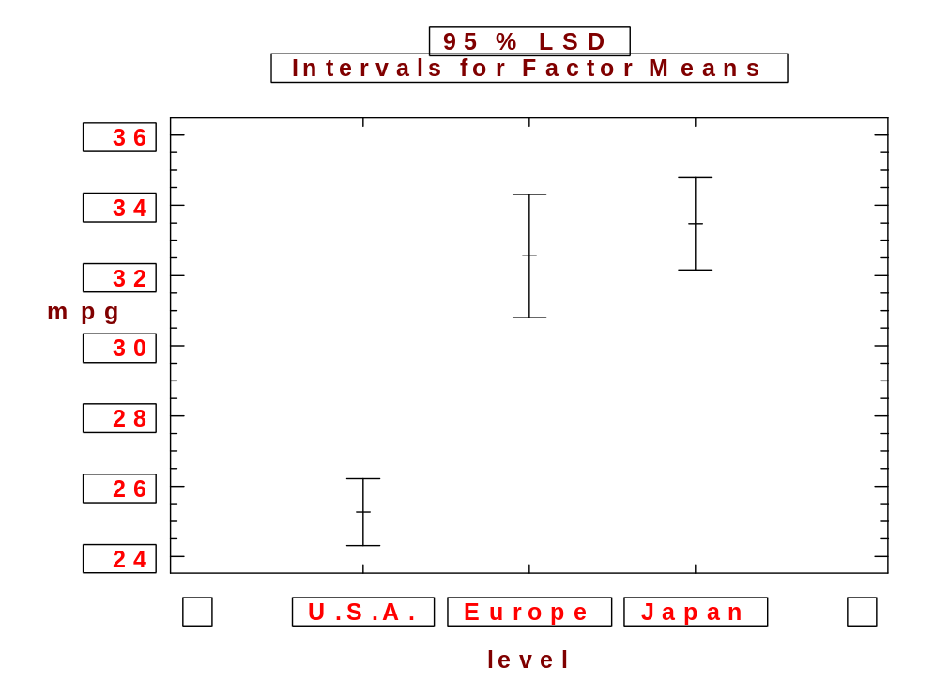

More than one factor car be used, consider for example the effect of year of manufacture as well as country of origin. This gives three sets of hypohesis statements, two for the main effects and one for the interaction between the main effects. These are:

Carrying out two way analysis of variance gives:

Analysis of Variance for mpg - Type III Sums of Squares
--------------------------------------------------------------------------------
Source of variation Sum of Squares d.f. Mean square F-ratio Sig. level
--------------------------------------------------------------------------------
MAIN EFFECTS
A:origin 1554.5504 2 777.27522 25.031 .0000
B:year 1100.8658 4 275.21644 8.863 .0000
INTERACTIONS
AB 252.19838 8 31.524798 1.015 .4274

RESIDUAL 4316.2133 139 31.051895
--------------------------------------------------------------------------------
TOTAL (CORRECTED) 8326.7535 153
--------------------------------------------------------------------------------
1 missing values have been excluded.
All F-ratios are based on the residual mean square error.

The main effects plot for year of manufacture is:

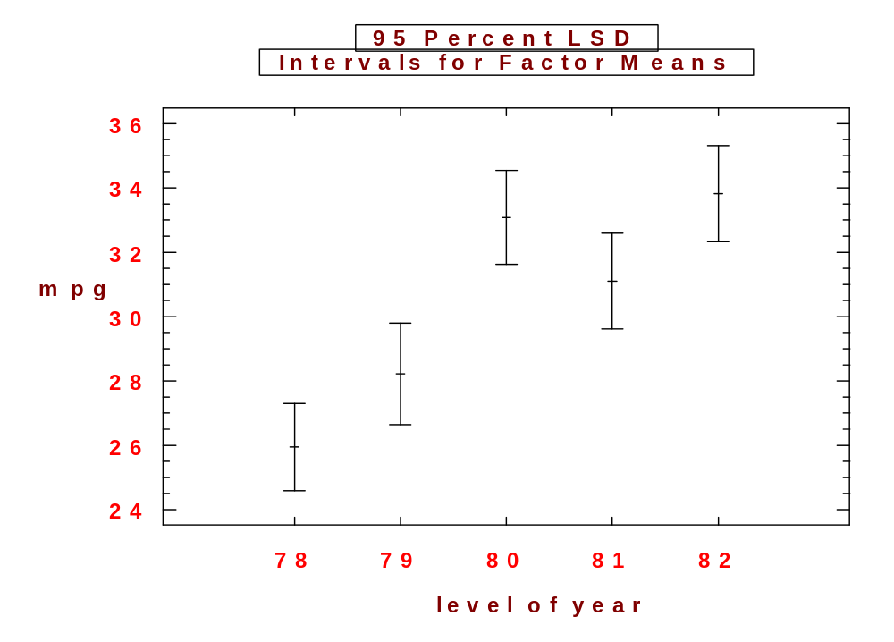
The main effect plot for origin is as the case for the oneway ANOVA. The interaction plot is:

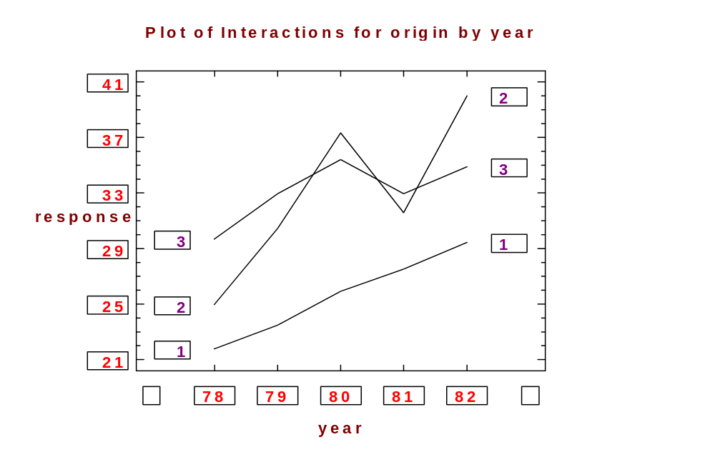

REFERENCES

Burr J.T. “The Tools of Quality”, Quality Progress, June, 64-67, 1990.

Hardesky J.L., “Productivity & Quality Improvement - A Practical Guide to Implementing Statistical Process Control”, McGraw-Hill, USA, 1988.

Hogg R.V. and Ledolter J., “Applied Statistics for Engineers and Physical Scientists”, 2nd Ed., Macmillan, New York, 1992.

Montgomery D.C., Introduction to Statistical Quality Control", Wiley, Chichester, 1991.

Ott R.L.,”An Introduction to Statistical Methods and Data Analysis”, Wadsworth Inc., Belmont, California, 1993.

Siegel A.F., "Statistics and Data Analysis", Wiley, Chichester, 1988.

Thompson J.R. and Koronacki J., “Statistical Process Control for Quality Improvement”, Chapman and Hall, London, 1993.

Wadsworth H.M. et al, “Modern Methods for Quality Control and Improvement”, Wiley, Chichester, 1986.

Vardeman S.B., “Statistics for Engineering Problem Solving”, PWS Publishing, Boston, 1994.

